Triathlon

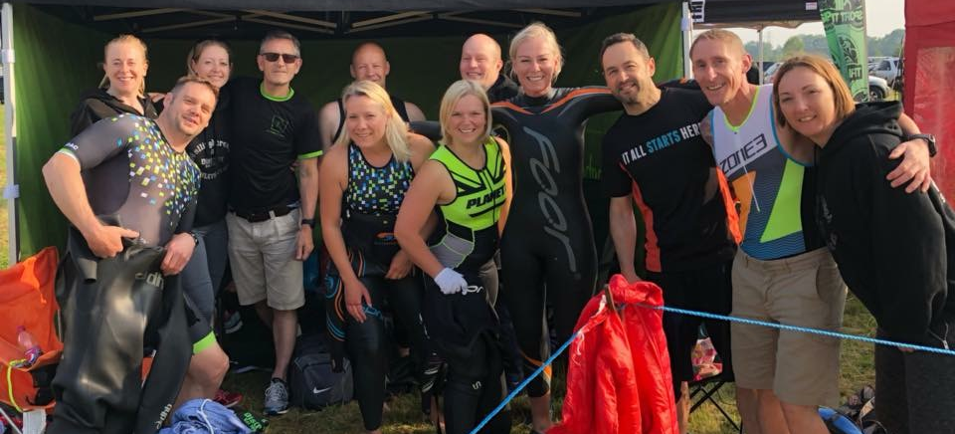

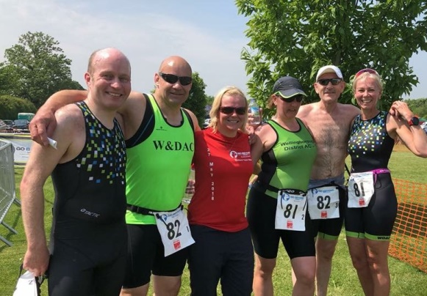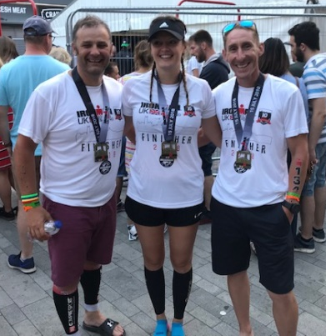

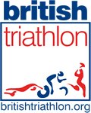
Wellingborough & District AC are affiliated to British Triathlon.
When applying for your Triathlon England membership and Race Licence (please remember to select Wellingborough &District AC as your club).
We are also affiliated to UK Time Trials so if you want to enter a cycle TT or two!!

Contacts
If you need to contact us regarding the Triathlon section, please contact Neil McDonald on neilm@wdac.org.uk

- News
- Club Championship
- Results

These can all be found on our members closed Facebook page - Click here

Training
- Run | Bike | Swim

Structured sessions with WDAC every Tuesday & Thursdays plus casual long runs and other runs at weekends posted on the main WDAC Facebook group
- Run | Bike | Swim

Summer – Monday night rides, normally in 2 or 3 groups to suit all speeds – look out on the Triathlon and WDAC Facebook pages for start, speeds and distances times etc.

Winter – Monday night – Mike Berry’s ‘house of pain’ Turbo sessions
- Run | Bike | Swim

Summer – We help to run and manage the fantastic Sywell Country Park Open Water facility – Saturday mornings 8 – 10am and Wednesday evenings 6 -7pm - £3 per session including parking, wetsuit hire available and RLSS and Anglian Water approved and accredited waters, fully lifeguarded and supervised open water swimming for all.

All bookable at https://www.northamptonshiresport.org/open-water-swimming

Winter – No fixed sessions or venues at the moment but watch this space – look out for casual groups on the Facebook pages – Corby 50m pool is a favourite training venue on Friday evenings in the winter.

Links

WDAC Facebook page

WDAC Triathlon Facebook page

Sywell Open Water swimming

https://www.northamptonshiresport.org/

https://www.corbyleisure.co.uk/corby-pool-information

https://www.britishtriathlon.org/

https://www.cyclingtimetrials.org.uk/

